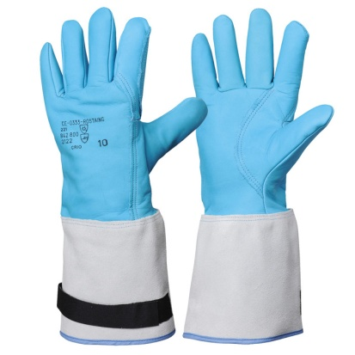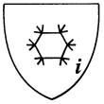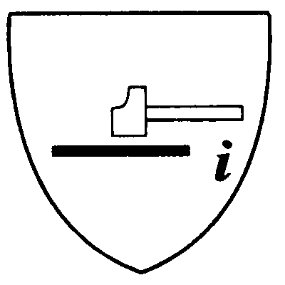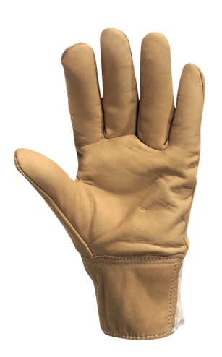

ROSTAING SA Tél : 04 74 46 07 15 Fax : 04 74 61 34 43

17, avenue Charles de Gaulle Tél : 0033(0)4 74 46 34 55 Fax : 0033 (0) 4 74 61 34 43

01800 VILLIEU LOYES MOLLON Mail : [contact@rostaing.fr](mailto:contact@rostaing.fr) Web : [www.rostaing.com](http://www.rostaing.com)

American cut five-finger glove with full index finger

Glove + thumb/index finger reinforcement in 1 mm thick cowhide, fire repellent

Glove lined with woollen fleece and hydrophilic, microporous insert

Total length 40 cm including a 15 cm split cow hide cuff.

Tightening band on cuff. Polyamide thread seams

Packaging: package of 5 pairs, box of 10 pairs

Available sizes: 8. 9. 10. 11

## THERMAL HAZARDS

**2** Convective cold out of four levels

**2** Contact cold out of four levels

**1** Waterproofness out of one level

Model meets the requirements of the European Standards:

EN 420 1994 General Requirements

EN 388 1994 Protection Against Mechanical

Hazards

EN 511 Protection Against the Cold

Homologation delivered by the notified

Organization IFTH/LYON

No 0072/011/162/05/97/0139

Model certified suitable for submersion in liquid nitrogen (method IFTH MR 019)

**MECHANICAL HAZARDS**

**2** Abrasion resistance out of four levels

**1** Blade cut resistance out of five levels

**2** Tear resistance out of four levels

**2** Puncture resistance out of four levels

**CRYOGENIC HANDLING**

**COLD HANDLING**

### DESCRIPTION & MAINTENANCE

**PROTECTION LEVEL**

**PERFORMANCE**

**WATERPROOF**

**HYDROPHILIC, MICROPOROUS MEMBRANE**

**SELF-GRIPPING RIBBON FOR TIGHTENING CUFF**

**PRODUCT ADVANTAGES**

##### CRIO

**USE**

**MECHANICAL HAZARDS**

Abrasion resistance: 2 out of 4 levels

Blade cut resistance: 3 out of 4 levels

Tear resistance: 4 out of 4 levels

Puncture resistance: 2 out of 4 levels

**DESCRIPTION & MAINTENANCE**

**HEAT AND FIRE**

Fire resistance: 2 out of 4 levels

Contact heat: 3 out of 5 levels

Convective heat: 4 out of 4 levels

Radiant heat: 2 out of 4 levels

Small splashes of molten metal: 2 out of 4 levels

Large splashes of molten metal: 2 out of 4 levels

Model meets the requirements of European standards:

EN 420 General Requirements

EN 388 Protection Against Mechanical Hazards

**wetcut/01**

**PROTECTION LEVELS**

**PERFORMANCES**

BREATHABLE LEATHER, WATER REPELLENT, ARTERY GUARD,

CUT RESISTANCE

**PRODUCT ADVANTAGES**

**USE :**

WORK SITES, LINEMEN,

WET ENVIRONMENT, CABLING, MAINTENANCE.

**Wet handling**

**Technical Sheet**